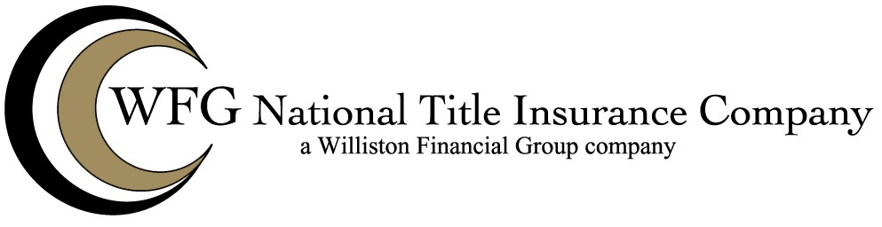

COVENANTS, CONDITIONS AND RESTRICTIONS – IMPROVED LAND

WFG National Title Insurance Company herein called “The Company”.

- The insurance provided by this endorsement is subject to the exclusions in Section 4 of this endorsement; and the Exclusions from Coverage, the Exceptions from Coverage contained in Schedule B, and the Conditions in the policy.
- For the purposes of this endorsement only,
  - “Covenant” means a covenant, condition, limitation or restriction in a document or instrument in effect at Date of Policy.
  - “Improvement” means a building, structure located on the surface of the Land, road, walkway, driveway, or curb, affixed to the Land at Date of Policy and that by law constitutes real property, but excluding any crops, landscaping, lawn, shrubbery, or trees.
- The Company insures against loss or damage sustained by the Insured by reason of:
  - A violation on the Land at Date of Policy of an enforceable Covenant, unless an exception in Schedule B of the policy identifies the violation;
  - Enforced removal of an Improvement as a result of a violation, at Date of Policy, of a building setback line shown on a plat of subdivision recorded or filed in the Public Records, unless an exception in Schedule B of the policy identifies the violation; or
  - A notice of a violation, recorded in the Public Records at Date of Policy, of an enforceable Covenant relating to environmental protection describing any part of the Land and referring to that Covenant, but only to the extent of the violation of the Covenant referred to in that notice, unless an exception in Schedule B of the policy identifies the notice of the violation.
- This endorsement does not insure against loss or damage (and the Company will not pay costs, attorneys' fees, or expenses) resulting from:
  - any Covenant contained in an instrument creating a lease;
  - any Covenant relating to obligations of any type to perform maintenance, repair, or remediation on the Land; or
  - except as provided in Section 3.c., any Covenant relating to environmental protection of any kind or nature, including hazardous or toxic matters, conditions, or substances.

This endorsement is issued as part of the policy. Except as it expressly states, it does not (i) modify any of the terms and provisions of the policy, (ii) modify any prior endorsements, (iii) extend the Date of Policy, or (iv) increase the Amount of Insurance. To the extent a provision of the policy or a previous endorsement is inconsistent with an express provision of this endorsement, this endorsement controls. Otherwise, this endorsement is subject to all of the terms and provisions of the policy and of any prior endorsements.

WFG NATIONAL TITLE INSURANCE COMPANY

By:
Authorized Signatory

